**5.I_8086 ADDRESSING MODES**

CS 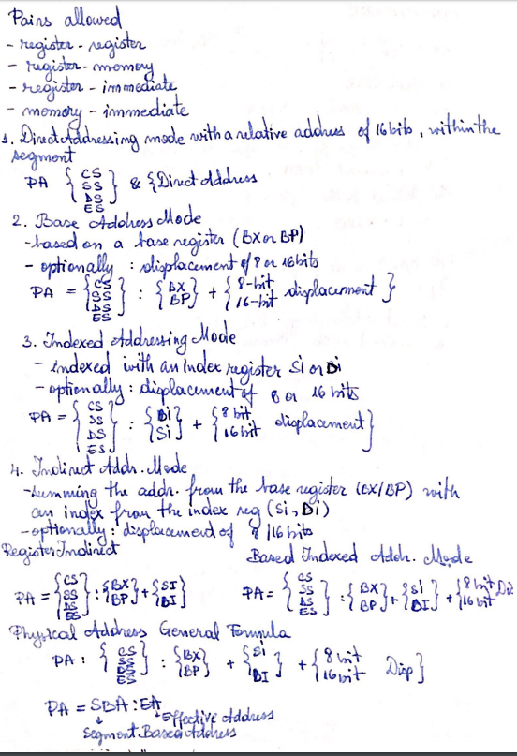

MOV AL, [BP+ 0100]

MOV AL, [BP+SI]

MOV AX, [BX+DI]

MOV AX, [SI+2000]

MOV AL, [DI+3000]

MOV AX, [DISP]

Intre []